**Stage 1 - Essential English 2020**

**Semester 2 Task 2: Responding to Texts: Magazine Cover Analysis**

**Response Structure**

* Magazine information and target audience
* Brief cover description and purpose
* The design conventions
* The language features

**Assessment Length: Maximum of 500 words written response essay, picture annotate, power point or oral.**

C1 Clarity and coherence of written and spoken expression, using appropriate vocabulary

C2 Demonstration of Grammatical Control

Cp2 Understanding the purpose, structure, and language features used in texts

An2 Identification and analysis of ways in which language features are used to create meaning in texts

**Purpose:** What is the purpose of your chosen magazine? Briefly describe it.

**Target Audience:** Who is the magazine for and how do you know this? What age, gender or type of person is targeted? Use evidence from the magazine to back up and support your statement. Evidence can include a direct quote.

**Structure and Conventions:** Use an annotated copy of your magazine cover to assist you with the analysis of the structure and conventions used. You are to ANALYSE the use of these conventions – asking the question WHY? Not just stating what conventions are.

**Language Features:** Analyse the language features used. Don’t just say what features were used, explain why and how they relate to the intended audience. Remember to use the language techniques table provided to help you with this.

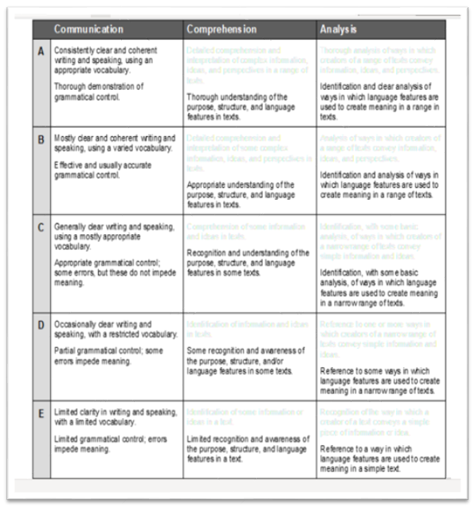

**Magazine Analysis – Key design points to write about**

[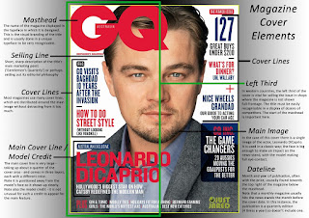](http://1.bp.blogspot.com/--TupkpH3KJg/Vpz5RfP8UcI/AAAAAAAAGoM/jEMOJOb-PwM/s1600/Magazine+Cover+Elements.jpg)**Genre specific lexis:** Words that an audience would associate with a specific genre. 'Banging' tunes'.

**Hyperbole:** Over exaggerated language that can make a text seem very good.   
'I've told you a million times'.

**Imperatives:** Words or phrases that contain a command or an order. 'Get your free gift NOW'.  
  
**Masthead:** In publishing refers to the flag, banner or the name of a magazine or newspaper printed in large type at the top of the front page. The masthead should also give a clue to the genre of the magazine. Kerrang for instance is the name of a music magazine and it sounds like a guitar being strummed. If the magazine is well known then the masthead may be obscured by the main image.

**Slogan:** making the reading feel familiar and part of a tribe that connects with them, oversells the brand – for example the best magazine for lovers of fashion. Generally states a promise or image to the customer for buying the magazine.

**Sell line:** is information on the cover of a magazine that tells the reader what extra they can get if they buy the magazine. Free gifts or competitions for example.

**Puff:** normally a bonus in the form of a give away, possibility, exclusive or draw card.

**Cover lines:** These usually run down the one or both sides and give the reader clues to what is inside the magazine. Their aim is to persuade the reader to buy. Cover lines must link to the genre and be enticing – consider the language used.

**Main image/central image:** The main image of a music magazine is usually a picture of a band or artist who is currently popular. Is the main image a natural shot or is it trying to sell something or make a point. Why has this image been used.

**Date, barcode, price:** All magazines should include these. The price should reflect the category (a, b, c1 or c2, d, e). of the primary target audience.

**A strip along the top of the page:** Includes information about more minor articles inside the magazine

**Mode of address:** Magazines often use genre specific lexis. They can make the reader feel exclusive, part of a group. Hyperbole is often used to attract a younger audience.

If the character on the main image is staring straight out at the audience then it is called a direct mode of address.

**The layout and design** can be formal or informal. This will depend on the house style of the magazine. Informal layout may include snapshots or paparazzi shots.

Formal layout may include photos that have been set up and taken in a studio. Also structured layout of messy and unconventional.

**Colour:**Magazines tend to have a house style which is used consistently. This can be created from a limited palette. Contract between the main image and text bright over dull or dark over bright, colour or greyscale and why.

**Font style and size:** This is also related to the genre and can be sophisticated or cartoony, depending on the target audience. Are there lots of different test types and sizes and colours or not and why?

**Social media:** Links to social media sites such as Facebook or Twitter are important and can prolong a reader's interest in the text.

**Product inserts:** They may have images of special designers or products they want to associate with the magazine to draw customers.

**Date and issue:** Many people value to magazines and collect them and this is valuable for referencing and showing how long the magazine has been published.

**Persuasive Language Techniques**

The creators of texts, including magazine covers, use a range of persuasive language techniques to influence potential buyers. These language techniques are aimed to target the audience for the magazine. When developing your writers statement, make sure you refer to any of these techniques. Remember to **EXPLAIN**your reasons for these choices. This will demonstrate that you understand why each technique/convention was chosen and how it relates to the target audience.

|  |  |  |  |
| --- | --- | --- | --- |
| **Name** | **Definition** | **Effect on Audience** | **Example** |
| **Denotation and Connotation** | Denotation is the dictionary meaning of a word.  Connotation is the ideas and feels associated with a word. It can be negative or positive. | The emotional associations people make with words paints a picture in the reader’s mind. | Denotation of ‘Small’ a size that is less than normal  Connotations of ‘Small’ could be tiny, minuscule or microscopic. These words are used in a sentence over small because of their connotations |
| **Evidence** | Factual, quantifiable or statistical proof. This adds assertion to what is being addressed. | Adds weight to an argument and makes it harder to disagree or disapprove. | ‘That smoking causes cancer is now an indisputable scientific fact’ |
| **Exaggeration** | Idea that is taken to the extreme. | By taking an image or idea to an extreme, the emotion associated is also enforced. | ‘The boss will die from embarrassment if this ever comes out’ |
| **Expert Opinion** | Recognised authority, such as an individual or group, who add credibility to an argument. | Suggests that specialist knowledge or ‘inside information’ supports the view being presented. | Dr Howard Jones, Director of Anti-Cancer Council, said today that….. |
| **Inclusive Language** | Language that identifies the author with the reader. Word such as we, our, us or all of us. | Makes the author seem like they are on the readers side. | ‘We want what is best for our children’ |
| **Repetition** | Continued use of a word or phrase used throughout an article/cover | Reinforces a particular point for the reader. Links the word or phrase with the idea. | ‘When they increased our bank charges, we did nothing. When they raised interest rates, we did nothing. When they closed branches, we did nothing. It is time to do something. |
| **Rhetorical Question** | Questions that do not demand an answer because the answer is obvious. | Links the reader to the arguments by leading them to agree with the writer’s assertion | ‘Who could possibly say no to that offer?’  ‘It sure is hot today, isn’t it?’ |
| **Statistics** | Facts and data about the idea/topic | Adds weight to an argument by showing that there are facts rather than opinion to back up the argument | ‘Perth’s water usage has decreased by 35%’ |
| **Alliteration** | Repetition of a constant sound | Most commonly used in headlines to grab attention. Often has a rhythm that helps to make them catchy. | ‘Geelong’s Gary Grabs Game’  The repeating sound is ‘G’ |
| **Anecdote** | A story that shows a point of view. Often these are personal stories. | Personalises and/or humanises the issue. Can draw the reader in when anecdotes are emotional and illustrate how the author has been affected by the issue. | ‘I recently took my son to his first football match. I was looking forward to sharing in the joy of his excitement. The crowd behavior, however: ruined that experience for us’ |
| **Appeal** | Designed to play on either positive or negative emotional feelings. | Targets the emotions or intellect of the reader. Appeals are specifically designed to provoke the audience by targeting the vulnerabilities or prejudices. Appeals can be made to people’s fears, beliefs, hopes, dreams, ambitions, affiliations and insecurities | Appeal to fear: Your child could be next    Appeal to values: They are trying to destroy our way of life.    Appeals to hope: By doing this you will secure your financial future. |
| **Colloquial language** | Common and informal language. Often reflects how people speak. | Friendly and familiar language disarms the reader and makes them feel comfortable. Puts the author at the same level as the reader. | It’s time for a fair go for all of us Aussie Battlers |
| **Cliché** | Expression that has been used so often it has lost effective meaning. | Makes the argument simple for the reader because the expression is so well known that they don’t have to analyse the meaning. | ‘We are taking the season one week at a time’ |
| **Denigration** | Attack on the reputation of a person or idea | Draws attention away from the issue and associates the opposition with harmful or irrational ideas. | ‘How can we listen to a man whose idea of culture is watching reality television while nursing a warm beer?’ |